

Birley Spa Academy
Attendance Policy

Policy/Procedure management log
Document name | Attendance Policy
Date approved | Trust approval Autumn Term 2026  AGB approval Autumn Term 2026
Date issued | Autumn Term 2026
Date of review | Autumn Term 2027

1. Aims
At Birley Spa Academy we are committed to meeting our obligation with regards to school attendance through our culture and ethos that values good attendance, including by:
- Promoting good attendance
- Reducing absence, including persistent and severe absence
- Ensuring every pupil has access to the full-time education to which they are entitled
- Acting early to address patterns of absence
- Building strong relationships with families to ensure pupils have the support in place to attend
- Promoting and supporting punctuality in attending lessons

2. Legislation and Guidance
This policy meets the requirements of the working together to improve school attendance from the Department for Education 2026 and refers to the DfE’s statutory guidance on school attendance parental responsibility measures. These documents are drawn from the following legislation setting out the legal powers and duties that govern school attendance:

- Part 6 of The Education Act 1996
- Part 3 of The Education Act 2002
- Part 7 of The Education and Inspections Act 2006
- The School Attendance (Pupil Registration) 9England) Regulations 2024
- The Education (parenting contracts and Parenting Orders) Regulations 2007
- The Education (Penalty Notices) (England) (Amendment) Regulations 2007 (and 2013 amendments)
- The Crime and Disorder Act 1998
- The Anti-Social Behaviour Act 2003
- The Sentencing Act 2020
- The Children’s and Young Persons Acts 1933 and 1963
- The Equality Act 2010

3. Roles and Responsibilities
*Full details of roles and responsibilities can be found in appendix 4.

3.1 Academy Trustees

Trustees are responsible for:

- Ensuring that there is a Trust wide strategy to improve attendance and as part of this strategy share effective practice on attendance management and improvement across academies.

Academy Governing Bodies (AGBs) are responsible for:

- Take an active role in attendance improvement, support the academy to prioritise attendance and work together to set a whole school culture
- Making sure academy leaders fulfil expectations and statutory duties
- Regularly reviewing and challenging patterns of attendance, compare with other local academies, identify areas of progress and where greater focus is needed
- Making sure staff receive adequate training on attendance
- Holding the Headteacher to account for the implementation of this policy

3.2 The Headteacher
The Headteacher is responsible for:

- Implementation of this policy at the academy
- Develop and maintain a whole school culture that promotes the benefits of good attendance
- Ensure that admissions and attendance registers are accurately completed and that registers are taken within 15 minutes of the start of each session
- Have robust daily procedures in place to follow up absence
- Monitoring absence data to identify patterns and trends and have a clear strategy in place to identify which pupils and pupil cohorts to focus on and measure impact of any intervention, including PA/SA and vulnerable groups
- Supporting staff with monitoring the attendance of individual pupils
- Ensure that there is a dedicated senior leader with overall responsibility for championing and improving attendance.
- Authorising the Local Authority issuing of fixed-penalty notices where necessary

3.3 The Senior Attendance Champion:
The designated senior leader is responsible for:

- Leading attendance across the academy
- Ensuring all academy-based staff complete their attendance responsibilities in line with statutory procedures and academy policy and procedures
- Set a clear vision for improving and maintaining good attendance and ensuring a whole school approach to attendance
- Evaluating and monitoring expectations and processes
- Having an oversight of data analysis and use strategic tools, such as the DfE data to inform practice, this includes use of benchmarking data, inclusion of young carers and expectations around specific cohorts.
- Devising specific strategies to address areas of poor attendance identified through data
- Arranging calls and meetings with parents to discuss attendance issues
- Lead formal conversations with parents
- Establish targeted intervention and support to pupils and families and measure the impact of such interventions

The designated senior leader responsible for attendance is the Headteacher and can be contacted via 0114 2399106.

3.4 The Attendance Officer/Attendance Lead
The academy attendance officer is responsible for:

- Monitoring and analysing attendance data (see section 7)
- Benchmarking attendance data to identify areas of focus for improvement
- Providing regular attendance reports to the Senior Attendance champion and academy staff and reporting concerns about attendance to the designated senior leader responsible for attendance and the Headteacher
- Working with the Local Authority and other partners to tackle persistent and severe absence

The attendance officer is Lynn Matthews and can be contacted via 0114 2399106.

3.5 [Class Teachers/Form Tutors]

Class teachers are responsible for recording attendance on a daily basis, using the correct codes, and submitting this information to the office by 9am.

3.6 Academy [Admin/Office] Staff
Academy [admin/office] staff will:
- Record all absence details received on a day-to-day basis and log it on the academy MIS system
- Transfer calls from parents to the Attendance Officer in order to provide them with more detailed support on attendance

3.7 Parents/Carers
Parents/carers are expected to:

- Make sure their child attends every day on time
- Call the academy to report their child’s absence before 8:45am on the day of the absence and each subsequent day of absence) and advise when their child is expected to return
- Provide the academy with 3 emergency contact numbers for their child and update accordingly
- Ensure that, where possible, appointments for their child are made outside of the academy day
- Only request a leave of absence in exceptional circumstances
- Attend meetings where attendance causes a concern or falls below national expectations

3.8 Pupils
Pupils are expected to:

- Attend every day on time

3.9 The Local Authority
The Local Authority is legally obliged to:

- Rigorously track local attendance data.
- Provide a strategic approach to improving attendance and ensure that it is a key focus of all frontline services
- Provide access to the School Attendance Support Team which provides the following core functions:
- Communication and advice
- Targeted support Meetings
- Multi-disciplinary support for families
- Provide each school with a named point of contact in the School Attendance Team who can support with queries and advice
- Enable opportunities to share effective practice
- Work with academies to issue legal interventions
- Monitor and improve attendance of children with a social worker through their virtual school

4. Recording Attendance
4.1 Attendance Register
At Birley Spa Academy, we keep an attendance register of all pupils on the academy roll.
We will take our attendance register at the start of the first session of each day and again after lunch. These registers will be taken at the same time of the day for all pupils in the morning and within 15 minutes of returning from lunch in the afternoon. It will mark whether every pupil is:
- Present
- Attending an approved off-site educational activity
- Absent
- Unable to attend due to exceptional circumstances

Any amendment to the attendance register will include:

- The original entry
- The amended entry
- The reason for the amendment
- The date on which the amendment was made
- The name and position of the person who made the amendment

DfE attendance codes can be found in appendix 1.
We will also record:
- Whether the absence is authorised or not
- The nature of the activity if a pupil is attending an approved educational activity
- The nature of circumstances where a pupil is unable to attend due to exceptional circumstances

We will keep every entry on the attendance register for 6 years after the date on which the entry was made.

The school day at Birley Spa Academy starts at 8:40am. Pupils must arrive by 8:35am every day.
The register for the first session will be taken at 8:40am and will be kept open until 9:10am. The register for the second session will be taken at:
EYFS | 12:40pm
KS1 | 12:50pm
Y3/4 | 1:10pm
Y5/6 | 1:25pm
and will be kept open for 30 minutes.
4.2 Unplanned Absence
The pupil’s parent/carer must notify the academy of the reason for the absence on the first day of an unplanned absence by 8:45am or as soon as practically possible by calling the Academy on 0114 2399106.
Parents/carers will be asked whether the child could come into school with medication.
We will mark absence due to illness as authorised unless we have a genuine concern about the authenticity of the illness. If the authenticity of the illness is in doubt, we may ask the pupil’s parent/carer to provide medical evidence, such as, prescription, appointment card or other appropriate form of evidence. This evidence will be used to help understand better the needs of the pupil and to help identify the most suitable provision in line with supporting pupils with medical conditions. We will not ask for medical evidence unnecessarily.

If the academy is not satisfied with the authenticity of the illness, the absence will be recorded as unauthorised and parents/carers will be notified of this in advance.

4.3 Planned Absence
Attending a medical or dental appointment will be counted as authorised as long as the pupil’s parent/carer notifies the academy in advance of the appointment. Parents should present the appointment card/text/email from the medical professional as far in advance as possible.
However, we encourage parents/carers to make medical and dental appointments out of school hours where possible. Where this is not possible, the pupil should be out of the academy for the minimum amount of time necessary and should always be in school before a later appointment or after a morning appointment.
The pupil’s parent/carer must also apply for any other type of term-time absence as far in advance as possible of the date or dates of the requested absence.
4.4 Lateness and Punctuality
A pupil who arrives late:
- Before the register has closed, will be marked as late, using the appropriate code ‘L’
- After the register has closed, 30 minutes or more after the start of the session, a pupil will be marked as absent, using the appropriate code ‘U’ which signifies that the pupil arrived after the official closing of the register and denotes an unauthorised absence.

4.5 Following up Unexplained Absence
Where any pupil we expect to attend does not attend, or stops attending without reason, the academy will:

- Call the pupil’s parent/carer on the morning of the first day of unexplained absence to ascertain the reason. If the academy cannot reach any of the pupil’s emergency contacts, the academy may contact the police or social care if relevant.
- Identify whether the absence is approved or not
- Identify the correct absence code to use and input it as soon as the reason for absence is ascertained – this will be no later than 5 working days after the session
- Call the parent/carer on each day that the absence continues without explanation to ensure proper safeguarding action is taken where necessary. If absence continues, the academy will consider involving the School Attendance Support Team and other partner agencies

4.6 Reporting to Parents/Carers
The academy will regularly inform parents about their child’s attendance and absence levels through parents’ evening. Parents/Carers will be contacted individually if their child’s attendance or punctuality drops below our target of 96%.

5. Authorised and Unauthorised Absence
5.1 Approval for Term-time Absence
Only exceptional circumstances warrant a leave of absence. Birley Spa Academy will consider each application individually taking into account the specific facts and circumstances and relevant background context behind the request. If a leave of absence is granted, it is for the Headteacher to determine the length of the time the pupil can be away from school. As Headteachers should only grant leaves of absence in exceptional circumstances, it is unlikely a leave of absence will be granted for the purposes of a family holiday.

Any request should be submitted as soon as it is anticipated and, where possible, at least six weeks before the absence, and in accordance with any leave of absence request form (Appendix 3), accessible via the school office. The Headteacher may require evidence to support any request for leave of absence.
Valid reasons for authorised absence may include:
- Illness and medical/dental appointments (see sections 4.2 and 4.3 for more detail)
- Religious observance – where the day is exclusively set apart for religious observance by the religious body to which the pupil’s parents belong. If necessary, the academy will seek advice from the parents’ religious body to confirm whether the day is set apart
- The pupil is a mobile child and their parent(s) is travelling in the course of their trade or business and the pupil is travelling with them. A mobile child is a child of compulsory school age who has no fixed abode and whose parent(s) is engaged in a trade or business of such a nature as to require them to travel from place to place.

5.2 Pupils with Medical Conditions or Special Educational Needs and Disabilities
In line with Section 19 of the Education Act 1996 the Local Authority (LA) have a duty to: “make arrangements for the provision of suitable education at school or otherwise than at school for those children of compulsory school age who, by reason of illness, or otherwise, may not for any period receive suitable education unless such arrangements are made for them.”
This applies to children and young people:
- who are of statutory school age and who
- are permanently resident in the local authority and
- who are not in school for 15 days or more, whether consecutive or cumulative due to ill health and
- where the health need and necessity for absence has been validated as necessary by a medical doctor
- will not receive a suitable full-time education unless the local authority makes arrangements for this

Health problems include: disabilities, physical illnesses, injuries and clinically defined mental health problems. Suitable medical evidence will be required, including details of the health problem, how long the condition is expected to last, the likely outcome, and a treatment plan. This must be provided by a suitable medical professional, normally a hospital consultant. However, where specific medical evidence is not available quickly, the local authority will liaise with other medical professionals (e.g. the child's GP), so that provision of education is not delayed.
5.3 Children Missing Education (CME)
The academy recognises that early intervention is necessary to identify the existence of any underlying safeguarding risk, and to help prevent the risks of a child going missing in education. The academy will:

- Follow absence procedures
- Make a referral to CME if information is obtained that the family have moved out of area, with no forwarding school/academy
- Make a referral to CME if a pupil has not returned after 10 days and there has been no contact with the family, despite efforts made by the academy
- Work closely with the Children Missing Education (CME) Officer to identify a pupil’s current whereabouts/destination
- Agree with CME an appropriate time and category to remove the child from the academy roll. This includes those children and young people who are expected to move swiftly into appropriate provision; this is in line with The Education (Pupil Registration) (England) (Amendment) Regulations 2016
- Contact the Local Authority via CME after 20 school days of absence, to discuss whether to remove a pupil from the academy roll. The final decision about removal from the academy roll remains with the Headteacher.
- The academy will create a ‘lost pupil’ record on the national Lost Pupil’s Database School to School (s2s) to assist future schools and Children Missing from Education Officers to identify and locate children
See Children missing in education guidance

5.4 Sanctions –

Notices to improve
The academy can use a notice to improve; it should be issued in line with processes set out by the local authority.

A Notice to Improve is a final opportunity for a parent to engage in support and improve attendance before a penalty notice is issued. If the national threshold has been met and support is appropriate but offers of support have not been engaged with by the parent or have not worked, a Notice to Improve should usually be sent to give parents a final chance to engage in support. A Notice to Improve does not need to be issued in cases where support is not appropriate and an authorised officer can choose not to use one in any case, including cases where support is appropriate but they do not expect a Notice to Improve would have any behavioural impact (e.g. because the parent has already received one for a similar offence).

The Notice to Improve is expected to include:
- Details of the pupil’s attendance record and details of the offences.
- The benefits of regular attendance and parents’ duty under section 7 of the Education Act 1996.
- Details of the support provided so far.
- Opportunities for further support and the option to access previously provided support that was not engaged with.
- A clear warning that a penalty notice may be issued or prosecution considered if attendance improvement is not secured within the improvement period.
- A clear timeframe for the improvement period of between 3 and 6 weeks.
- Details of what sufficient improvement within that timeframe will look like.
- The grounds on which a penalty notice may be issued before the end of the improvement period.

National Threshold for issuing penalty notice
The academy can refer parents to the local authority where they do not ensure that children attend school. Parents can be fined for the unauthorised absence of their child from school, where the child is of compulsory school age.
The national threshold is 10 sessions of unauthorised absence in a rolling period of 10 school weeks. One school day contains 2 sessions.

A school week means any week in which there is at least one school session. This can be met with any combination of unauthorised absence (e.g. 4 sessions of holiday taken in term time plus 6 sessions of arriving late after the register closes all within 10 school weeks). These sessions can be consecutive (e.g. 10 sessions of holiday in one week) or not (e.g. 6 sessions of unauthorised absence taken in 1 week and 1 per week for the next 4 weeks). The period of 10 school weeks can also span different terms or school years (e.g. 2 sessions of unauthorised absence in the Summer Term and a further 8 within the Autumn Term).

A penalty notice is an out of court settlement which is intended to change behaviour without the need for criminal prosecution. If repeated penalty notices are being issued and they are not working to change behaviour they are unlikely to be most appropriate tool. Therefore, from autumn term 2024, only 2 penalty notices can be issued to the same parent in respect of the same child within a 3 year rolling period and any second notice within that period is charged at a higher rate:
• The first penalty notice issued to a parent in respect of a particular pupil will be charged at £160 if paid within 28 days. This will be reduced to £80 if paid within 21 days.
• A second penalty notice issued to the same parent in respect of the same pupil is charged at a flat rate of £160 if paid within 28 days.
• A third penalty notice cannot be issued to the same parent in respect of the same child within 3 years of the date of issue of the first. In a case where the national threshold is met for a third time (or subsequent times) within those 3 years, alternative action should be taken instead. This will often include considering prosecution but may include other tools such as one of the other attendance legal interventions.

6. Strategies for Promoting Attendance
We always celebrate and promote good attendance for our children as it has such a direct link to future success as an adult. If a child has 100% attendance in any given week, their name is published in the newsletter. Children can earn certificates each term if their attendance is at 96% or above. If the class collectively achieves 96% attendance and above in a week, this is tracked on a chart. If they achieve this every week for a half term, they can earn a class reward.
Certificates and stickers are awarded for children whose attendance improves. We work with the local authority where necessary to ensure sustained improvement for children whose attendance is impacting on their wellbeing, progress, confidence, friendships and learning.

7. Attendance Monitoring
- Attendance data is tracked regularly.
- We will use DfE data tools to inform intervention, such as attendance bandings and comparison reports to bench mark against similar schools
- Use PowerBi to analyse current attendance (add to how this is used)

7.1 Monitoring Attendance
The academy will:
- Monitor attendance and absence data trends on a fortnightly, half-termly, termly and yearly basis in relation to whole cohorts and distinct pupil groups
- Monitor individual pupil attendance, absence and punctuality on a daily and weekly basis
- Identify whether or not there are particular groups of children whose absences may be a cause for concern
- Pupil-level absence data will be collected daily and published at national and local authority level through the DfE's school absence national statistics releases. The underlying academy-level absence data is published alongside the national statistics. The academy will compare attendance data to the national average, and share this with the governing board

7.2 Analysing Attendance
The academy will:
- Analyse attendance and absence data using SIMS/PowerBi regularly to identify pupils or cohorts that need additional support with their attendance, and use this analysis to provide targeted support to these pupils and their families
- Look at historic and emerging patterns of attendance and absence, and then develop strategies to address these patterns

7.3 Using Data to Improve Attendance
As poor attendance is habitual, prevention and early intervention is crucial. The key to this is regular data analysis to both identify and provide immediate additional support to pupils or pupil cohorts that need it, and to look at historic and emerging patterns across the school and develop strategies to address them.

The academy will as a minimum:
- Monitor and analyse weekly attendance patterns and trends and deliver intervention and support in a targeted way to pupils and families.
- This should go beyond headline attendance percentages and should look at individual pupils, cohorts and year groups (including their punctuality) across the school to help schools achieve their responsibilities under the Public Sector Equality Duty. When analysing patterns, some schools, especially secondary schools, may wish to look further into patterns of attendance within a session to ensure all pupils are attending all timetabled lessons
- Use this analysis to provide regular attendance reports to class teachers to facilitate discussions with pupils and to leaders (including any special educational needs coordinators, designated safeguarding leads and pupil premium leads)
- Undertake frequent individual level analysis to identify the pupils who need support and focus staff efforts on developing targeted actions for those cases. This should not just focus on persistent and severe absence, but look at all severities of absence to identify pupils who can be supported earlier before patterns become entrenched
- Conduct thorough analysis of half-termly, termly, and full year data to identify patterns and trends. This should include analysis of pupils and cohorts and identifying patterns in uses of certain codes, days of poor attendance and where appropriate, subjects which have low lesson attendance
- Benchmark their attendance data (at whole school, year group and cohort level) against local, regional, and national levels or performance of similar schools to identify areas of focus for improvement.
- Devise specific strategies to address areas of poor attendance identified through data. This may, for example, include pupils in a year group with higher than average absence or for pupils eligible for free school meals if their attendance falls behind that of their more advantaged peers
- Monitor in the data the impact of school wide attendance efforts, including any specific strategies implemented. or specific cohorts that schools have sought to target. The findings should then be used to evaluate approaches or inform future strategies
- Provide data and reports to support the work of the board or governing body
- Academies should decide which cohorts of pupils should be included in their data analysis based on their context and school population. This may include: boys and girls, year groups, pupils with special educational needs or disabilities, pupils with a social worker or who are looked-after by the local authority, pupils who are young carers, pupils eligible for free school meals, and any pupils from backgrounds (including ethnicities, religions or beliefs, or sexual orientations where applicable) in the school community that have, or have historically had, lower attendance than their peers
- Academies may wish to make use of the View Your Education Data tool to compare attendance outcomes of different cohorts of pupils at a local and national level to identify where intervention is most needed
- Attendance returns: providing the local authority with the names and addresses of all pupils of compulsory school age who fail to attend school regularly or have been absent for a continuous period of ten school days where their absence has been recorded with one or more of the codes statistically classified as unauthorised (G, N, O, and/or U). Local authorities must agree the frequency that attendance returns are to be provided with all schools in their area. This should be no less frequently than once per calendar month.
- Sickness returns: providing the local authority with the full name and address of all pupils of compulsory school age who have been recorded with code I (illness) and who the school has reasonable grounds to believe will miss 15 days consecutively or cumulatively because of sickness. Only one sickness return is required for a continuous period of sickness in a school year. This is to help the school and local authority to agree any provision needed to ensure continuity of education for pupils who cannot attend because of health needs, in line with the statutory guidance on arranging education for children who cannot attend school because of health needs.

7.4 Reducing Persistent and Severe Absence
Persistent absence is where a pupil misses 10% or more of school, and severe absence is where a pupil misses 50% or more of school.

The academy will:
- Work with local communities (including voluntary and community groups) to help remove the barriers to attendance that families experience. In some cases, families will experience the same or similar barriers to attendance for multiple children who attend different schools in the area. As such, it is of mutual benefit for such schools to work together where possible. This will be particularly beneficial in supporting transition between feeder schools.
- Use attendance data to find patterns and trends of persistent and severe absence
- Hold regular meetings with the parents of pupils who the academy (and/or local authority) considers to be vulnerable, or are persistently or severely absent, to discuss attendance and engagement
- Provide access to wider support services to remove the barriers to attendance
- Use all available legal means at the academies disposal to challenge situations where there is severe and persistent absence

8. Policy Review
This policy will be reviewed as guidance from the local authority or DfE is updated, and as a minimum annually by the Attendance Champion. At every review, the policy will be approved by the AGB.

9. Links with Other Policies
This policy links to the following policies:
- Child protection and safeguarding policy
- Behaviour policy
- Equality policy
- Supporting pupils with medical conditions

Appendix 1: attendance codes
The following codes are taken from the DfE’s guidance on school attendance.

Attending the school
Code | Definition | Scenario
/ | Present (am) | Pupil is present at morning registration
\ | Present (pm) | Pupil is present at afternoon registration
L | Late arrival | Pupil arrives late before register has closed

Attending a place other than school
Code | Definition | Scenario
K | Attending a place other than at school | Attending education provision arranged by the local authority
B | Attending any other approved educational activity | Pupil is attending a place for an approved educational activity that is not a sporting activity or work experience
D | Dual registered at another school | Pupil is attending a session at another setting where they are also registered
P | Sporting activity | Pupil is participating in a supervised sporting activity approved by the school
V | Educational trip or visit | Pupil is on an educational visit/trip organised, or approved, by the school and supervised by a member of school staff
W | Work experience | Pupil is on a work experience placement

Code | Definition | Scenario

Absent - Leave of Absence
C | Leave of absence for exceptional circumstances | A leave of absence must not be granted unless there are exceptional circumstances
C1 | Regulated performance or employment abroad | Leave of absence for the purpose of participating in a regulated performance or undertaking regulated employment abroad
C2 | Part-time | Leave of absence for compulsory school age pupil subject to a part-time timetable
H | Authorised holiday | Pupil has been allowed to go on holiday due to exceptional circumstances
J1 | Interview | Leave of absence for the purpose of attending an interview for employment or for admission to another educational institution
M | Medical/dental appointment | Pupil is at a medical or dental appointment
S | Study leave | Leave of absence for the purpose of studying for a public examination
X | Not required to be in school | Pupil of non-compulsory school age is not required to attend
Absent – other authorised reasons
Code | Definition | Scenario
I | Illness (not medical or dental appointment) | The pupil is unable to attend due to illness (both physical and mental health related). Schools should advise parents to notify them on the first day the child is unable to attend due to illness.
E | Excluded | Suspended or permanently excluded and no alternative provision made
T | Pupil is a mobile child | Parent travelling for occupational purposes
R | Religious observance | A day exclusively set apart for religious observance
Absent – unable to attend school due to unavoidable cause
Code | Definition | Scenario
Q | Unable to attend the school because of a lack of access arrangements | Unable to attend because the local authority has failed to make access arrangements
Y1 | Unable to attend due to transport normally provided not being available | The pupil is unable to attend because the school is not within walking distance of their home and the transport to and from the school that is normally provided for the pupil by the school or local authority is not available.
Y2 | Unable to attend due to widespread disruption to travel | The pupil is unable to attend the school because of widespread disruption to travel caused by a local, national, or international emergency
Y3 | Unable to attend due to part of the school premises being closed | Part of the school premises is unavoidably out of use and the pupil is one of those that the school considers cannot practicably be accommodated in those part of the premises that remain in use
Y4 | Unable to attend due to the whole school site being unexpectedly closed | In response to adverse weather
Y5 | Unable to attend as pupil is in criminal justice detention | See statutory guidance for correct usage
Y6 | Unable to attend in accordance with public health guidance or law | See statutory guidance for correct usage
Y7 | Unable to attend because of any other unavoidable cause | See statutory guidance for correct usage
Absent – unauthorised absence
Code | Definition | Scenario
U | Arrived in school after registration closed | Where a pupil has arrived late after the register has closed but before the end of session.
O | Absent in other or unknown circumstances | Where no reason for absence is established or the school is not satisfied that the reason given is one that would be recorded using one of the codes statistically classified as authorised.
G | Holiday not granted by the school | The school has not granted a leave of absence and the pupil is absent for the purpose of a holiday.
N | Reason for absence not yet established | Where absence is recorded as code N in the attendance register, the correct absence code should be entered as soon as the reason is ascertained, but no more than 5 school days after the session. If a reason for absence cannot be established within 5 school days, schools must amend the pupil’s record to Code O.

Administrative codes
Code | Definition | Scenario
# | Planned whole school closure | Whole school closures that are known and planned in advance
Z | Prospective pupil not on admission register | To enable schools to set up registers in advance of pupils joining the school to ease administration burdens.

Appendix 2:
Flow chart of promoting good attendance
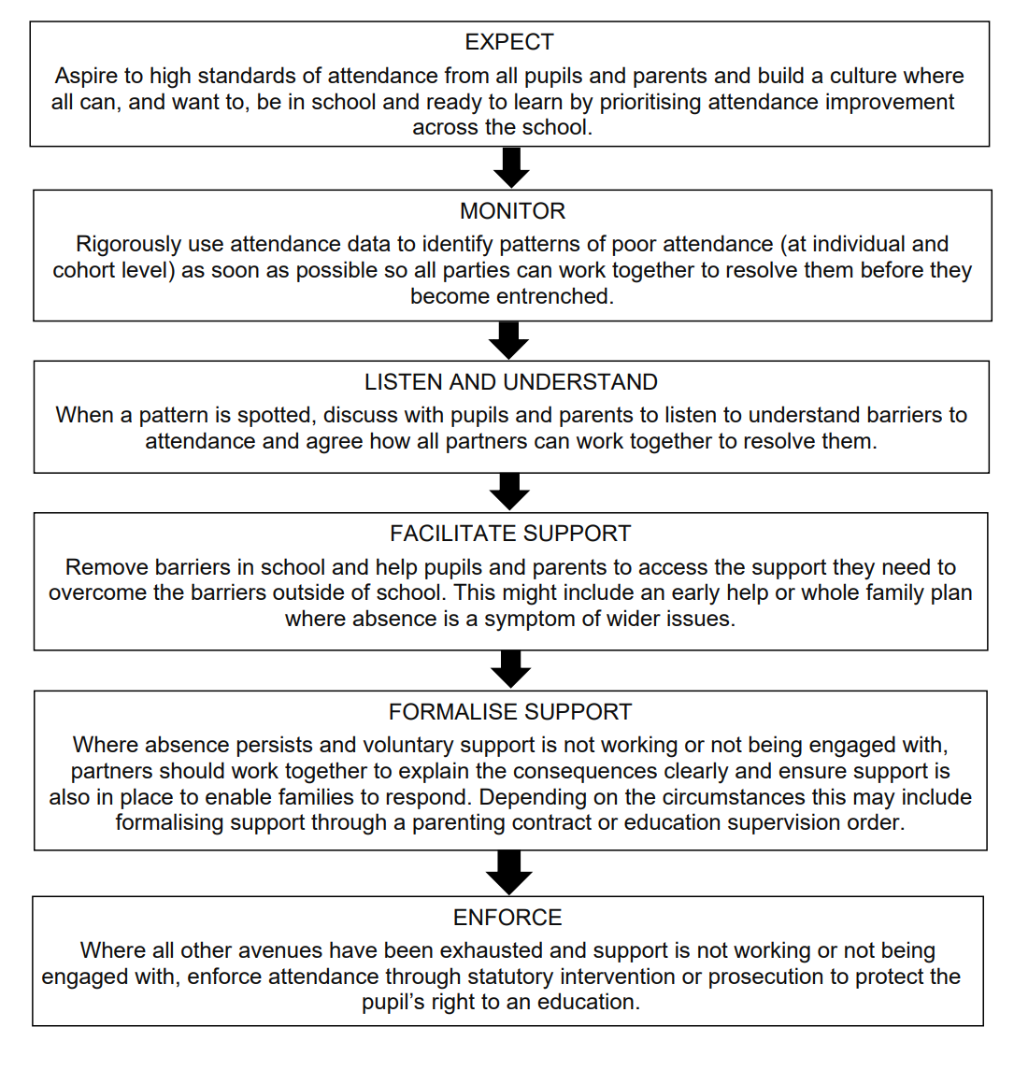

Appendix 3:
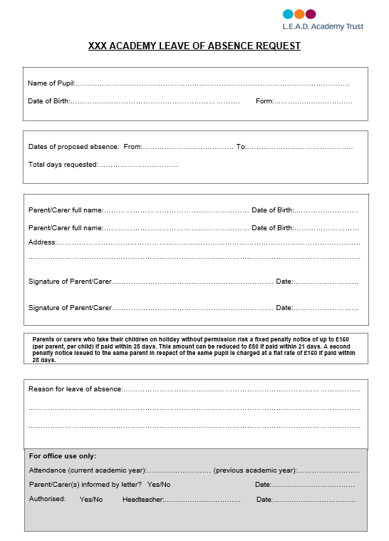

Appendix 4 – Roles and responsibilities document (working together to improve attendance) Table of responsibilities

